Assignment 6

Instruction: Assignment must be neatly presented in a Word document including tables or graphs from Excel.

Q1.
In the Productivity dataset, the dependent variable is Productivity, and the independent variables are labeled, respectively, Teamwork, Jobknowl, Jobauthr, Wrkdyssk, and Recogawd.

- Briefly state your hypotheses.
- Provide a brief description of variables (univariate analysis). Also, examine the bivariate associations between Productivity and Teamwork, Jobknowl, Jobauthr, Wrkdyssk, and Recogawd. Examine the bivariate relationships that exist between all possible pairs of these variables.

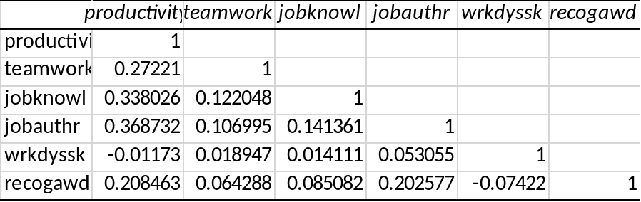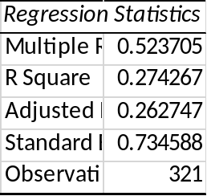
+0.70. A strong uphill (positive)
+0.70. A strong uphill (positive)
r=0.52 which is positive and moderate strong
correlations between the independent variables and the dependent variables

- Examine whether Teamwork, Jobknowl, Jobauthr, Wrkdyssk, and Recogawd are statistically associated with Productivity. For this purpose, conduct a multiple regression in which the dependent variable is Productivity and the independent variables are Teamwork, Jobknowl, Jobauthr, Wrkdyssk, and Recogawd. What do you conclude?
ANOVA
 | df | SS | MS | F | Significance F
Regression | 5 | 64.23851 | 12.8477 | 23.80879 | 2.62E-20
Residual | 315 | 169.9803 | 0.53962
Total | 320 | 234.2188
H0: There is no association between the independent variables and dependent variable
H1: There is association between the independent variables and dependent variable
2.62E-20<0.05 hence it is statistically significant we reject the null hypothesis and adopt the alternative hypothesis.
Conclude that teamwork, Jobknowl, Jobauthr, Wrkdyssk, and Recogawd are statistically associated with Productivity

- You now wish to include the effect of department in your analysis. To do this, you must add to the model dummy variables for the first three departments, Dept1, Dept2, and Dept3 and rerun the analysis. Are departments associated with employees’ perceptions of productivity controlled for all other factors of the model? If yes, which departments are significantly associated with employees’ perceptions of productivity?
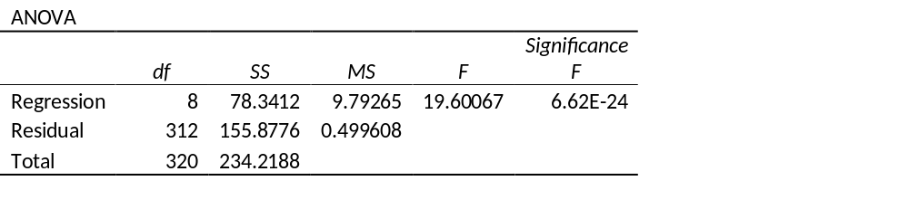
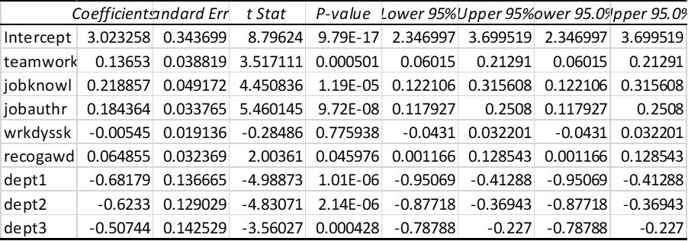

The results show that it all the independent remains significantly associated with productivity improvement p=6.6 E-24(p < .01). Although there are differences among departments that are associated with productivity, these differences do not affect the statistical significance of variables shown above. These factors further increase the adjusted R², which is now 33%.Though the departments are statistically predictors ,they are negatively associated with productivity(coefficients:dept1= -0.68,dept2= -0.62,dept3= -0.51)
Department 1,2 and 3 are statistically significant at p<0.05.
All the departments are significantly associated with employees’ perceptions of productivity

e) Provide a complete write-up of the regression. (1) Identify which variables are significant and at what level. Identify the adjusted R-square statistic (is it a strong or weak association?). Also, discuss the regression coefficients. What do you conclude? (2) Plot the standardized residuals against the standardized predicted values. What do you conclude? (3) To examine the possibility of multicollinearity, examine the bivariate correlations among the independent variables. What do you conclude? Given the significance of coefficients, is multicollinearity a problem here?

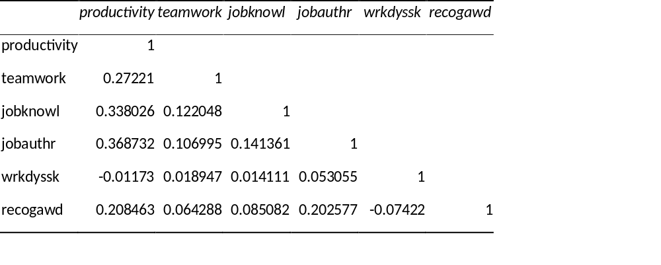
A positive indicates as one variable increases so does the other
A negative indicates as one variable increases the other decreases

Teamwork is a positive and significant (b=0.14, s.e=034p=0.000). Jobknoel is a positive and significant (b=0.14, s.e=0.04,p=1.19e-05,p<0.05), jobauthr is a positive and significant (b=0.18, s.e=0.18,s.e=0.03,p=9.72E-08,p<0.05),
Wrkdysk is statistically insignificant (b= -0.00545,s.e=0.02,p=0.78).It is negatively associated with the productivity.
Recogawd is statistically significant(b= -0.51,s.e=0.32,p=0.001).It is negatively associated with productivity.
All the independent variables have weak association with productivity (r<0.52)
From the table of the regression coefficient. We use the coefficients to come up with a model
Y=3. 02+0.14(team)+0.22(jobknowl)+0.18(jobauthr)-0.005(wrkdyssk)+0.064(recogawd)-0.68(dept1)-0.6233(dept2)-0.51(dept3)

Q2.
Use the Time dataset. This exercise illustrates the use of dummy variables and includes a test of multicollinearity. The dataset contains observations from 35 hypothetical cities regarding the use of citizen focus groups in various departments (Focus). The data are based on a survey. Most variables are index variables taken from different survey questions. The variables are defined as follows: Focus = A composite measure of the breadth and depth of the use of citizen focus groups in a city. Varies from 0 (low) to 20 (high). Mgrint = A measure of the interest of the city manager in obtaining citizen-based feedback. Varies from 1 (low) to 4 (high). Pubcompl = A measure of public complaints about the quality and effectiveness of a wide range of municipal services. Varies from 1 (low) to 8 (high). Budget = Indicates whether municipal budgets have increased in the past two years. Values are –1 = decrease in budget; 0 = no change in budget; 1 = increase in budget. Size = City size. Varies from 1 = small to 7 = large. Region = An indicator variable of the region in which the city is located. Values: 1 = Northeast; 2 = South; 3 = Midwest; 4 = West. In this analysis, you wish to understand which variables cause cities to use citizen-based focus groups.

- Briefly state your hypotheses.
- H0: There is no relationship between the use of focus groups and the interest of managers in obtaining citizen-based feedback [or any other independent variable], controlled for the effect of public complaints, budgets, size, and region [all other independent variables listed here].
- HA: There is a relationship between the use of focus groups and the interest of managers in obtaining citizen-based feedback [or any other independent variable], controlled for the effect of public complaints, budgets, size, and region [all other independent variables listed here]

- Provide a brief description of variables (univariate analysis). Also, examine the bivariate associations between Focus and Mgrint, Pubcompl, Budget, and Size. Examine the bivariate relationships that exist between all possible pairs of these variables.
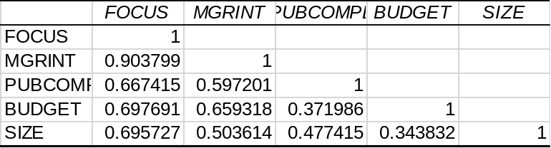

Ans: This is straightforward, providing a write-up of the mean and frequency distributions of each of these variables. Many students want a template, which tells them what to write in an automatic fashion (“the mean is . . .”). Rather, I try to get them to search for conclusions (e.g., “about half the cities are small . . .”). For example, Univariate analysis of the index measure of focus groups shows that this variable varies from 0 to 20, with a mean of 10.11. About a quarter, 25.7%, have scores up to 4.0, and 25.7% have scores greater than or equal to 15.
The bivariate associations show strong correlations between the independent variables and the dependent variable. They also show a rather strong correlation between Budget and Mgrint (r = .659)

- Examine whether Mgrint, Pubcompl, Budget, and Size are statistically associated with the use of focus groups. For this purpose, conduct a multiple regression in which the dependent variable is Focus and the independent variables are Mgrint, Pubcompl, Budget, and Size. What do you conclude?
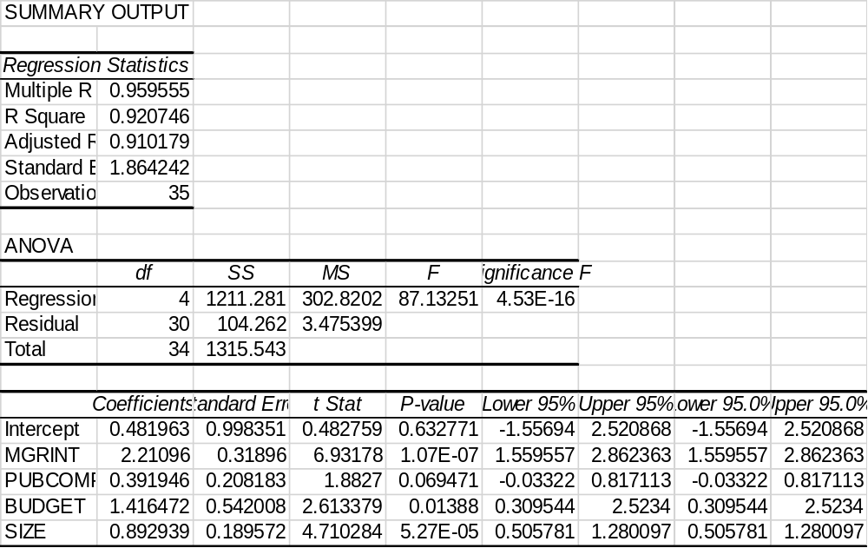

The independent variables are statistically significant at 4.53E-16<0.05. There is a strong positive correlation r=0.95 r>0.5, between Mgrint, Pubcompl, Budget, and Size and focus.
- You now wish to include the effect of region in your analysis. To do this, you must make Region a dummy variable. Assume you wish to compare the effect of the different regions with Midwest. To make the dummy variables for the Northeast, South, and West, you must either recode the data for each region or enter the data manually. Through either of these techniques, add Northeast, South, and West to your model and rerun the analysis.
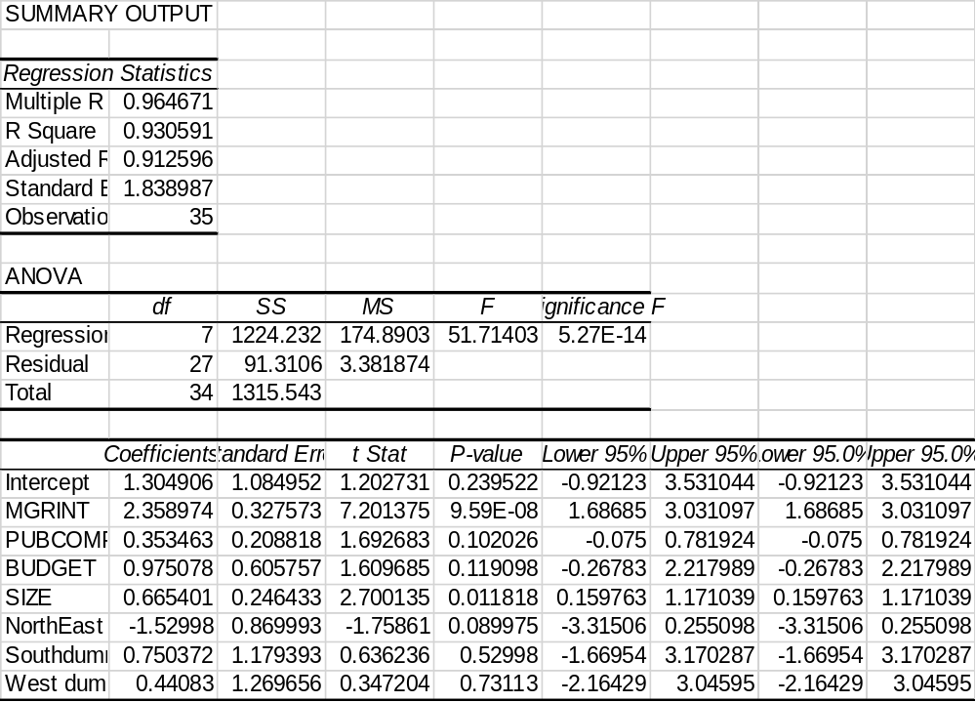
The model is statistically significant p=5.3E-14<0.05.
- Provide a complete write-up of the regression. (1) Identify which variables are significant and at what level. Identify the adjusted R-square statistic (is it a strong or weak association?). Also, discuss the regression coefficients. What do you conclude? (2) Plot the standardized residuals against the standardized predicted values. What do you conclude? (3) To examine the possibility of multicollinearity, examine the bivariate correlations among the independent variables. What do you conclude? Given the significance of coefficients, is multicollinearity a problem here?
y = a + b1x1 + b2x2 + b3x3 + b4x4 + b5d1+b6d2+b7d3+E where d represent dummy variables. y estimate= a + b1x1 + b2x2 + b3x3 + b4x4 + b5d1+b6d2+b7d3
FOCUS = 1.30+2.35* MGRINT+0.35 *PUBCOMPL+0.98*BUDGET+0.67*SIZE-1.53*NorthEast+0.75*South+0.44*West
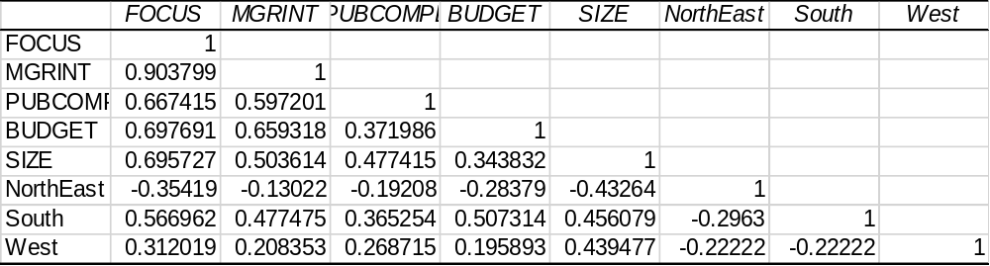

Adjusted squared =0.91
There is a very strong relationship between the independent and the composite measure of the breadth and depth of the use of citizen focus groups in a city (dependent) r=0.96

Manager’s interest is a positive and significant (b=2.36, s.e=0.33p=9.5E-08) . Public complaints is a positive and statistically insignificant (b=0.35, s.e=0.21p=0.102). Municipal budgets is a positive and statistically insignificant (b=0.98, s.e=0.61p=0.12). City size is a positive and statistically significant (b=0.66, s.e=0.24p=0.01)p<0.05. Region(North East) is a negative and statistically insignificant (b= -1.5, s.e=0.86p=0.089,p>0.05).Region(South) is a positive and statistically insignificant (b=0.75, s.e=1.18,p=0.53,p<0.05).
Region(west) is a positive and statistically insignificant (b=0.44, s.e=1.26p=0.73).

Q3.
Use the Time dataset. Time series data are common in program evaluation and public policy. These data examine the impact of a law that, among other things, increases jail time for those convicted of driving under the influence (DUI). The dataset contains the following variables:

Fatal = Traffic fatalities per 100,000 miles driven.
Year = Year of traffic fatalities measured.
Short = A dummy variable identifying when the policy intervention occurred, namely, in 1980 when a law was passed that requires mandatory jail time for DUI. The values are 0 = pre–law adoption (pre-1980) and 1 = post–law adoption (post-1980).
Long = A dummy variable identifying the number of years of post–policy adoption. The values are 0 for pre–law adoption, 1 for 1980, 2 for 1981, 3 for 1982, and so forth. This variable gives weight to the long-term effect of policy.
Jailtime = Days of jail time served by offenders as a result of the law.

Note: Although increased jail time is the primary effect of the program, data from other aspects of the program (such as midnight checkpoints) are not available to the researcher. The variables Short and Long model these unknown effects.

- You wish to evaluate whether the new law has been effective. You model the effect on fatalities and explore the possibility of autocorrelation in time series data. Hence, Fatal = f(Short, Long, Jailtime). Run the regression analysis. What do you conclude?

The model Fatal = f(Short, Long, Jailtime) shows positive autocorrelation: the Durbin-Watson test statistic is 0.814 (with N = 16 and k = 3, dl = 0.86 and du = 1.73).

- Now, take the trend variable into account. Add Year as an independent variable to your list. What do you conclude about adding the trend variable? Provide a complete write-up of the regression.
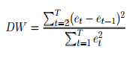

The Durbin Watson test reports a test statistic, with a value from 0 to 4, where:
2 is no autocorrelation.
0 to <2 is positive autocorrelation (common in time series data).
>2 to 4 is negative autocorrelation (less common in time series data).

When the variable Year is added (hence, Fatal = f(Short, Long, Jailtime, Year), the Durbin-Watson test statistic is 2.27, suggesting a negative autocorrelation. The variable Long is significant (p < .05).

